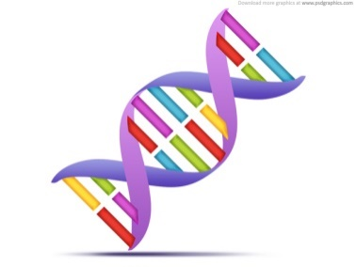Name: _______________________________

**Forensic Science**

**DNA Fingerprinting Unit Review**

1. Can people have the same DNA profile? Explain.

2. List 5 ways DNA fingerprinting can be useful:

1. _______________________________________________________________________________
2. _______________________________________________________________________________
3. _______________________________________________________________________________

d. _______________________________________________________________________________

e. _______________________________________________________________________________

3. DNA fingerprinting became a tool for criminal investigations in the (circle one)

1940’s 1960’s 1970’s 1980’s 2000’s

4. What are some examples of where DNA can be found in the body?

1. __________________________
2. __________________________
3. __________________________
4. __________________________
5. __________________________

5. The analysis of chromosomes is known as k______________________________.

6. What does DNA stand for?_____________________________________________.

7. Where in a cell is DNA found?__________________________________________.

8. A segment of DNA that codes for a protein is called a __________________.

9. What are the three parts of a DNA molecule? Label the three parts of a DNA molecule in the picture provided.

a. _____________________________________

b. _____________________________________

c. _____________________________________

10. What 4 bases make up DNA molecules?

1. __________________________
2. __________________________
3. __________________________
4. __________________________

11. Scientifically, describe the shape of a DNA molecule_______________________________

12. Humans have ___________ chromosomes.

13. _________________________ DNA exists in the form of a circular loop and, unlike

nuclear DNA, is inherited only from the mother.

14. Which statements are true? Circle the true statements.

1. The DNA in a person's blood is the same as the DNA in the skin cells and saliva.

2. Each person's DNA is different from every other individual's.

3. DNA can be found in all the cells in our bodies except the blood cells.

4. DNA can have forensic value even if it is decades old.

5. DNA evidence was first used to get a conviction in a trial in 1987.

15. The non-coding sections of our DNA are areas with great variation. Describe the

two types of non-coding sections used in DNA analysis:

16. Who is Dr. Alec Jeffreys?

17. DNA evidence is considered **individual/class** (circle one) evidence.

18. Explain how trace evidence can still be used for DNA analysis:

19. List four factors that may affect DNA evidence.

1. ________________________
2. ________________________
3. ________________________
4. ________________________

20. Put the steps of the DNA fingerprinting process in the correct order using # 1-4

______ DNA is cut by restriction enzymes

______ DNA is extracted from cells

______ Electrophoresis

______ Fragments are amplified using PCR

21. What does **CODIS** stand for? What types of DNA profiles are put into **CODIS**? __________________________________________________________________________________

__________________________________________________________________________________

22. **Crime Scene Analysis:**

Case #1: A stolen car was found on the side of the road with an empty bottle of Sprite. Detectives were able to collect enough DNA from the saliva left on the top of the bottle to create a DNA fingerprint. Below are the DNA fingerprints from the crime scene and two suspects who were seen near the abandoned car (NOTE: Bam HI and HIND III are 2 different types of restriction enzymes)

|  |  |  |
| --- | --- | --- |
| **Crime Scene DNA Sample** | | |
|  | **Bam HI** | **HIND III** |
| 100  75  50  25  0 |  |  |

|  |  |  |
| --- | --- | --- |
| **Sally “Sticky” Fingers** | | |
|  | **Bam HI** | **HIND III** |
| 100  75  50  25  0 |  |  |

|  |  |  |
| --- | --- | --- |
| **Bubba “Ballistic” Ray** | | |
|  | **Bam HI** | **HIND III** |
| 100  75  50  25  0 |  |  |

1. Who stole the car? __________________­­­______

2. How do you know? ______________________________________________________________________________________________________________________________

Case #2: A mother files a lawsuit for child support against a man she claims is the father of her child. The man claims that he has no children and does not even know the woman and so shouldn’t have to pay child support. Below are the DNA fingerprints of the child, the mother and the man. Remember, children receive half of their DNA from their mother and the other half from their father.

|  |  |  |
| --- | --- | --- |
| **Child’s DNA** | | |
|  | **Bam HI** | **HIND III** |
| 100  75  50  25  0 |  |  |
| **The Man’s DNA** | | |
|  | **Bam HI** | **HIND III** |
| 100  75  50  25  0 |  |  |

1. Could the man be the father of this child?

2. How do you know?

|  |  |  |
| --- | --- | --- |
| **Mother’s DNA** | | |
|  | **Bam HI** | **HIND III** |
| 100  75  50  25  0 |  |  |

23. During gel electrophoresis, which strands move slowest? fastest?

Slowest: ______________________________

Fastest: _______________________________

24. When might mitochondrial DNA be used over nuclear DNA?

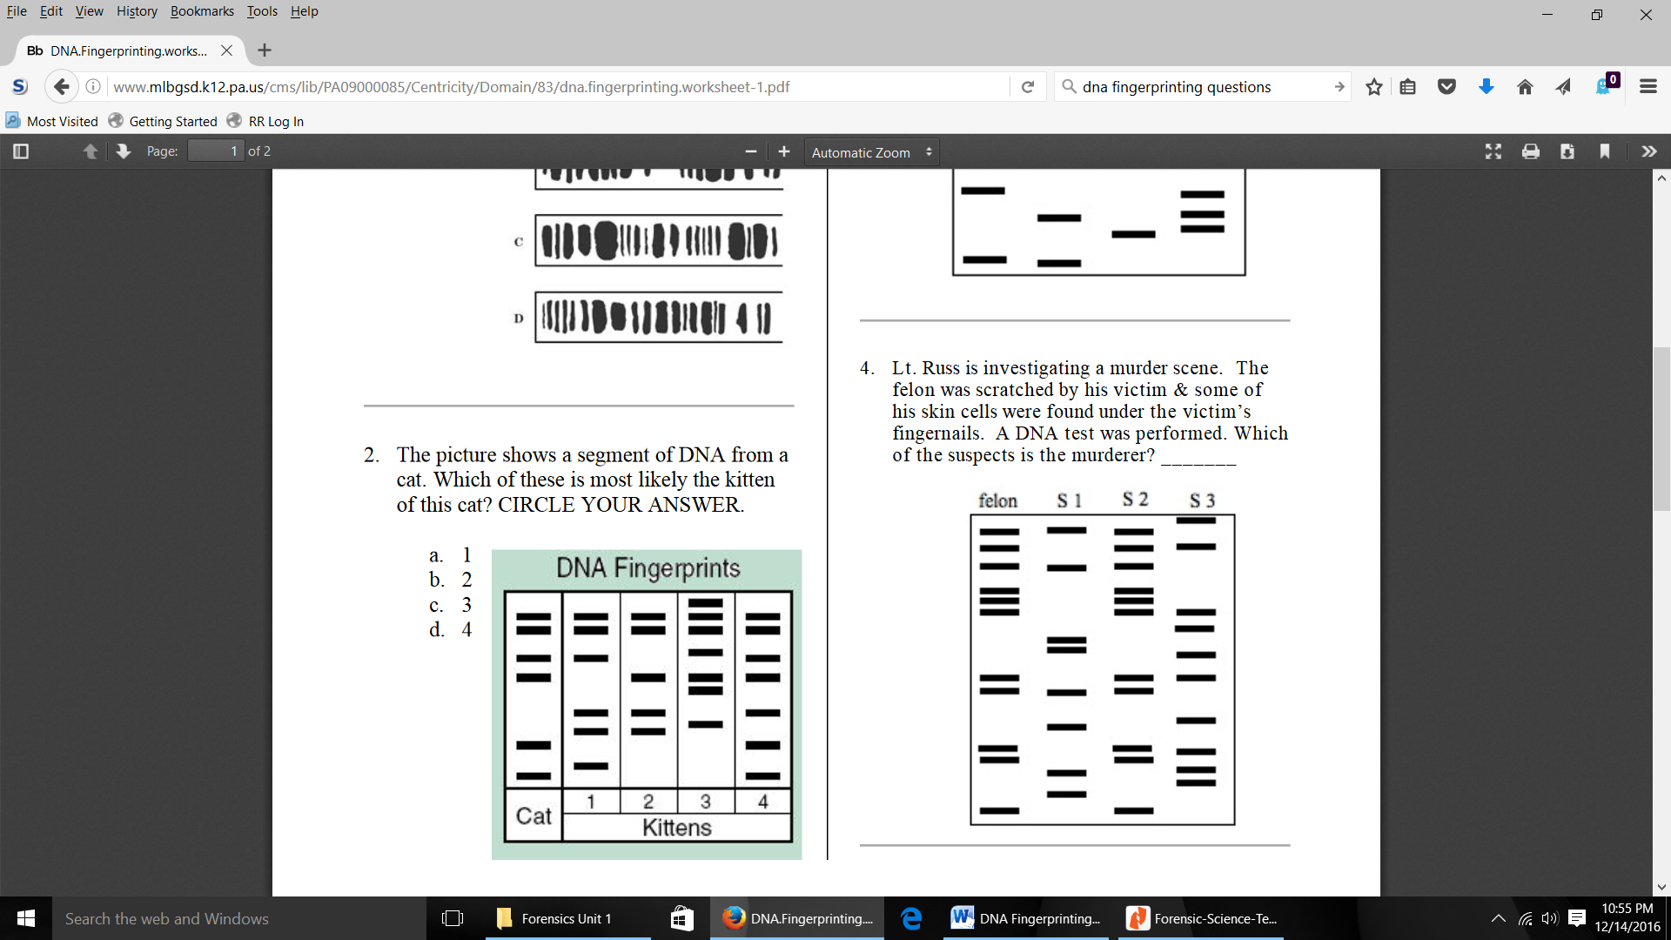25. Lt. Russ is investigating a murder scene. The felon was

scratched by his victim & some of his skin cells were

found under the victim’s fingernails. A DNA test was

performed. Which of the suspects is the murderer?

_________________________________________________

26. Compare the bands of each set of parents to each of the babies and determine which baby belongs to which set of parents. Line up the bands and illustrate

which bands each baby inherited from its mother and from its father.

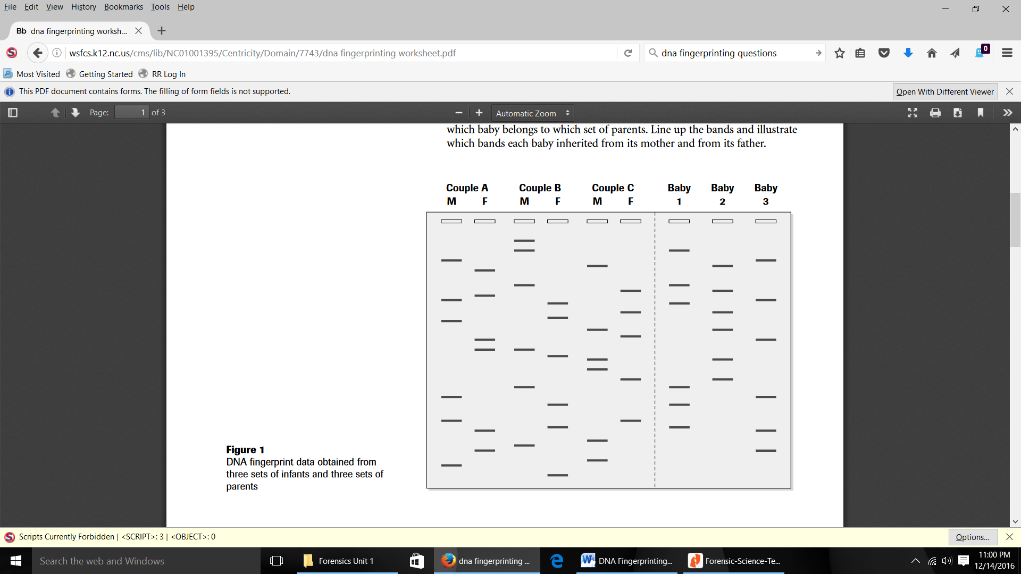

27. What is the purpose of using the polymerase chain reaction (PCR) method?

28. Read and describe the case of Nancy Hodge in your notes, and explain why this case was significant in terms of DNA fingerprinting.

29. Describe the BTK case and how DNA profiling helped catch Dennis Radar.